📘 Travel Agency Slack Bot: Documentation
The solution is a conversational slack bot driven by middleware automation. It replaces static forms with a natural chat experience, using AI to "humanize" the interaction while retaining strict logic for data routing.
The Stack:
- Frontend: Slack (Enterprise Messenger)
- Middleware/Brain: n8n (Automation Engine)
- Data Source: HubSpot (CRM / Booking Data)
- Intelligence: OpenAI / ChatGPT (Natural Language Generation)
- Backend: Jira Service Management (Ticket Resolution)

Installation Guide
This guide walks you through setting up all components required for the [Your Agency] Slack Bot system.

Prerequisites
Before starting, ensure you have:
- Slack workspace admin access
- n8n instance (cloud or self-hosted) with admin access
- HubSpot account with API access
- Jira Service Management instance with admin access
- OpenAI API account with API key

1. Set Up Slack Bot

Step 1.1: Create Slack App
- Navigate to Slack API: https://api.slack.com/apps
- Click "Create New App"
- Select "From scratch"
- Configure basic information:
  - App Name: [Your Agency] Bot (or your preferred name)
  - Workspace: Select your target workspace
- Click "Create App"

Step 1.2: Configure OAuth & Permissions
- Go to "OAuth & Permissions" in the sidebar
- Scroll to "Scopes" → "Bot Token Scopes"
- Add the following scopes:
  - app_mentions:read - View messages that mention the bot
  - channels:history - View messages in public channels
  - channels:read - View basic channel information
  - chat:write - Send messages as the bot
  - groups:history - View messages in private channels
  - im:history - View direct messages
  - im:read - View basic information about direct messages
  - im:write - Start direct messages
  - users:read - View people in the workspace
- Scroll up to "OAuth Tokens"
- Click "Install to Workspace"
- Review permissions and click "Allow"
- Copy the "Bot User OAuth Token" (starts with xoxb-)
  - ⚠️ IMPORTANT: Save this token securely - you'll need it for n8n
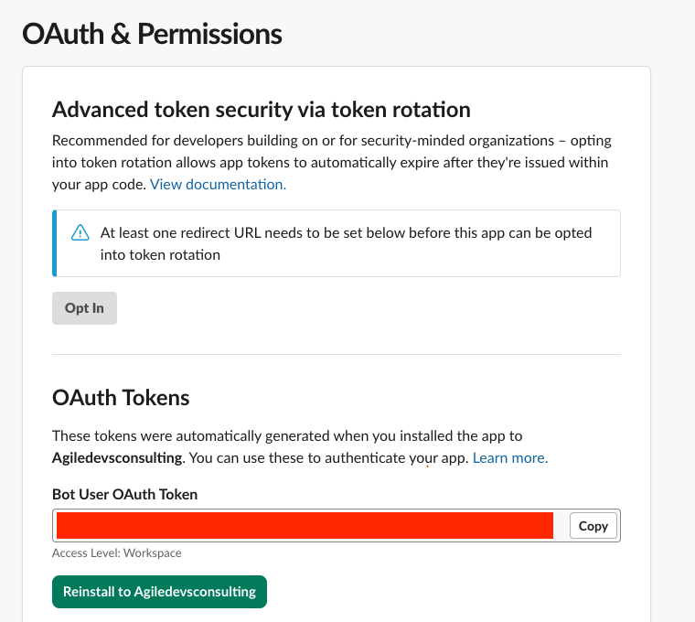

Step 1.3: Enable Socket Mode (Optional)
If using Socket Mode instead of webhooks:
- Go to "Socket Mode" in sidebar
- Toggle "Enable Socket Mode" to ON
- Create an app-level token with connections:write scope
Note: This guide uses Event Subscriptions (webhooks), so Socket Mode is optional.

Step 1.4: Configure Basic Information
- Go to "Basic Information" in sidebar
- Under "Display Information", add:
  - App icon: Upload bot avatar/logo
  - Description: "[Your Agency] booking assistant - helping guests with their travel bookings"
  - Background color: Choose your brand color
- Copy the "Signing Secret" under "App Credentials"
  - ⚠️ IMPORTANT: Save this - needed for webhook verification (optional security feature)

Step 1.5: Configure Event Subscriptions
- Go to the Slack API: https://api.slack.com/apps
- Select your [Your Agency] Bot app
- Go to "Event Subscriptions" in the sidebar
- Toggle "Enable Events" to ON
- On n8n, copy the production webhook URL
- Paste the n8n production webhook URL into the “Request URL” field. It it returns a “Verified” status, you’re good to go.
- Open "Subscribe to bot events” Add event names:
  - app_mentions:read
  - message.channels
  - message.groups
  - message.im
- Save and re-install the Slack bot app / If prompted to reinstall, click the reinstall link and approve

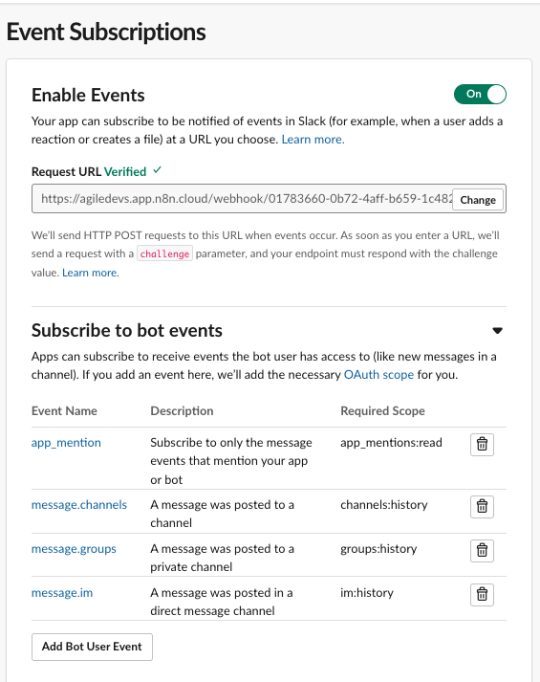

Step 1.6: Invite Bot to Channels
- In your Slack workspace, go to the channel where you want the bot
- Type: /invite @[Your Agency] Bot (or your bot's name)
- Press Enter
- The bot should appear in channel members list

Step 1.7: Get Bot User ID
- Go to your Slack workspace
- Find the bot in the Apps section or search for it
- Right-click the bot name → "View profile"
- Click the "..." menu → "Copy member ID"
- Save this ID (format: U0A0S9PP6R3)
  - You'll need this for filtering bot messages in the router

2. Installing n8n Workflow JSONs

Note - If you're using n8n version 2.0 or later, there's a new Publish workflow paradigm. The "Save" button now only saves your edits without pushing to production. You must click "Publish" to make the workflow live. Make sure all three workflows are published, not just saved and active.

Step 2.1: Import Workflows
- Log into your n8n instance
- Navigate to "Workflows" in the sidebar
- For each workflow file provided (workflow-c-router.json, workflow-a-fetcher.json, workflow-b-qna-jira.json): a. Click "+ Add Workflow" or "Import from File" b. Select the JSON file c. Review the imported workflow d. Click "Save" (give it a descriptive name if needed)
- Verify all three workflows imported:
  - ✅ [Your Agency] Slack Event Router - SLACK WEBHOOK
  - ✅ [Your Agency] Workflow A - "The Fetcher"
  - ✅ [YourAgency]Bot – Q&A + Jira Creation - MAIN

Step 2.2: Initial Workflow Review
Before activating / publishing, review each workflow:
- Check for missing credentials (red warning indicators)
- Verify node connections are intact
- Note any placeholder values that need updating
⚠️ DO NOT activate/publish workflows yet - credentials must be configured first.

3. Connecting Slack to n8n

Step 3.1: Create Slack Credential in n8n
- In n8n, go to "Credentials" (gear icon in sidebar)
- Click "+ Add Credential"
- Search for "Slack"
- Select "Slack API"
Using Slack API:
- Configure credential:
  - Credential Name: Slack - [Your Agency] Bot
  - Access Token: Paste the Bot User OAuth Token (from OAuth & Permissions → Bot User OAuth Token)
  - Signature Secret: Paste the Signing Secret (from Basic Information → App Credentials)
  - Click "Save"
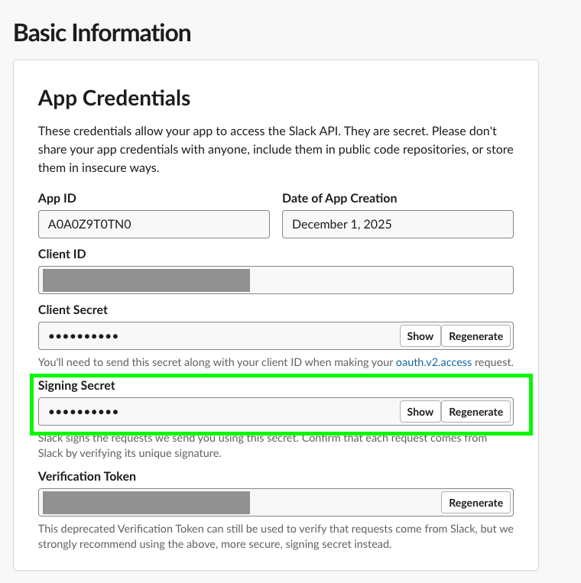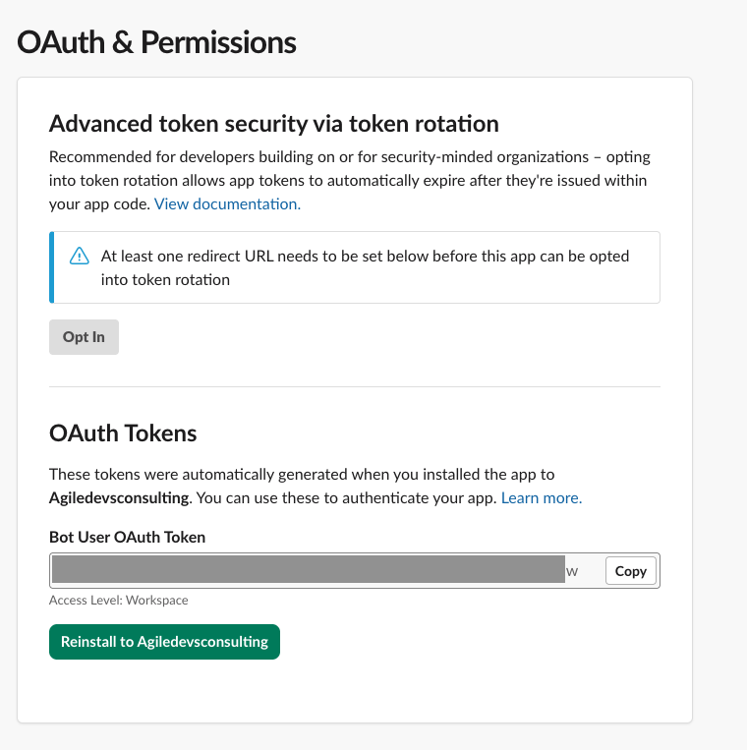
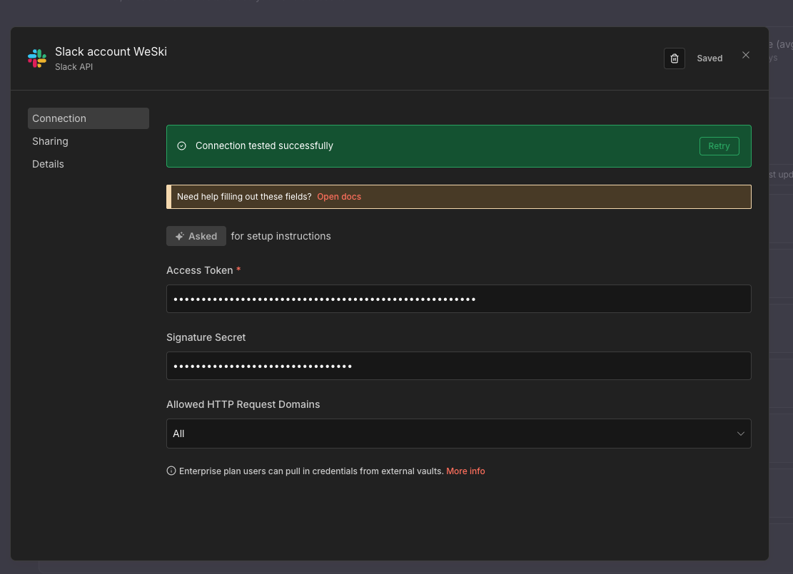

Step 3.2: Apply Slack Credentials to the entry / Router Workflow
In the router workflow – “[Your Agency] Slack Event Router - SLACK WEBHOOK”
- Open the workflow
- Click on the Slack Trigger node
- Under "Credential to connect with", select the credential you created for the Slack API
- Save the workflow

4. Connecting Jira to n8n

Step 4.1: Create Jira API Token
- Log into your Jira account
- Go to: https://id.atlassian.com/manage-profile/security/api-tokens
- Click "Create API token"
- Give it a label: n8n [Your Agency] Bot Integration
- Click "Create"
- Copy the token immediately
  - ⚠️ IMPORTANT: This is shown only once - save it securely

Step 4.2: Get Jira Instance Details
You'll need:
- Jira Domain: Your Jira URL (e.g., yourcompany.atlassian.net)
- Email: The email address associated with your Jira account
- Project Key: The Jira project where tickets will be created (e.g., SUPPORT, SERVICE)
To find your Project Key:
- Go to your Jira instance
- Navigate to Projects → Select your service desk project
- The project key appears in the URL: https://yourcompany.atlassian.net/browse/SUPPORT
- In this example, SUPPORT is the project key

Step 4.3: Create Jira Credential in n8n
- In n8n, go to "Credentials"
- Click "+ Add Credential"
- Search for "Jira"
- Select "Jira Software Cloud API" or "Jira Service Management"
- Configure credential:
  - Credential Name: Jira - [Your Agency] Service Desk
  - Jira Version: Select Cloud
  - Email: Your Jira account email
  - API Token: Paste the token from Step 4.1.6
  - Domain: Your Jira domain (e.g., yourcompany.atlassian.net)
  - Click "Save"

Step 4.4: Apply Jira Credentials to Workflow B
- Open Workflow B (Q&A + Jira)
- Find the Jira node (usually "Jira - Create Issue")
- Click the Jira node
- Under "Credential to connect with", select: Jira - [Your Agency] Service Desk
- Configure Jira node parameters:
  - Project: Select or enter your project key (e.g., SUPPORT)
  - Issue Type: Select Service Request or Task (depending on your setup)
  - Additional fields as needed for your Jira configuration
- Save workflow

Step 4.5: Test Jira Connection
- Click "Execute node" on the Jira node
- If successful, you'll see the created issue details
- If it fails, check:
  - API token is correct
  - Domain is correct (no https:// prefix)
  - Email matches the token owner
  - Project key exists and you have permission

5. Connecting HubSpot to n8n

Step 5.1: Create HubSpot Private App
- Log into your HubSpot account
- Go to Settings (gear icon in top right)
- Navigate to: Integrations → Private Apps
- Click "Create a private app"
- Configure the app:
  - App name: n8n [Your Agency] Bot Integration
  - Description: Integration for [Your Agency] bot to access deal information

Step 5.2: Configure Scopes (Optional)
Under the "Scopes" tab, enable these permissions:
CRM Scopes:
- ✅ crm.objects.deals.read - Read deals
- ✅ crm.objects.contacts.read - Read contacts (if needed)
- ✅ crm.schemas.deals.read - Read deal properties
Standard Scopes:
- ✅ oauth - Basic OAuth access
Click "Create app" at the bottom.

Step 5.3: Get Access Token
- After creation, you'll see a dialog with your Access Token
- Copy the token (starts with pat-na1- or similar)
  - ⚠️ IMPORTANT: Save this securely - shown only once
- Click "Continue creating"
- Review the app details and click "Show token" if you need to view it again

Step 5.4: Identify Deal Properties
You need to know which HubSpot property stores your Group ID:
- Go to Settings → Objects → Deals
- Click "Properties"
- Search for your Group ID field (might be named group_id, booking_id, reservation_number, etc.)
- Note the internal property name (shown in the property details)
  - This is what you'll use in n8n filters

Step 5.5: Create HubSpot Credential in n8n
- In n8n, go to "Credentials"
- Click "+ Add Credential"
- Search for "HubSpot"
- Select "HubSpot API"
- Configure credential:
  - Credential Name: HubSpot - [Your Agency] Deals
  - Authentication: Select API Key
  - API Key: Paste the access token from Step 5.3.2
  - Click "Save"
Alternative - Using OAuth (if required):
- Select OAuth2 instead
- Follow the OAuth flow to authorize n8n access to HubSpot

Step 5.6: Apply HubSpot Credentials to Workflows
In Workflow A (The Fetcher):
- Open the workflow
- Find the HubSpot node (usually "HubSpot - Search Deals")
- Click the node
- Under "Credential to connect with", select: HubSpot - [Your Agency] Deals
- Configure the search filter:
  - Resource: Deal
  - Operation: Search or Get All
  - Filters: Add filter for your Group ID property
    - Property: Your Group ID field name (e.g., group_id)
    - Operator: EQ (equals)
    - Value: {{ $json.event.text.match(/\d+/)[0] }} (extracts number from message)
- Save workflow
In Workflow B (Q&A + Jira):
- Repeat the process for any HubSpot nodes
- Ensure the same Group ID property is used
- Save workflow

Step 5.7: Test HubSpot Connection
- In Workflow A, click "Execute node" on the HubSpot node
- If using test data, provide a sample Group ID
- Verify the node returns deal data
- If it fails, check:
  - API key is correct
  - Private app has correct scopes
  - Deal property name matches exactly
  - Deals exist in HubSpot with that property populated

6. Connecting OpenAI to n8n

Step 6.1: Get OpenAI API Key
- Log into OpenAI: https://platform.openai.com
- Go to API Keys: https://platform.openai.com/api-keys
- Click "+ Create new secret key"
- Name it: n8n-[your-agency]-bot
- Copy the key immediately (starts with sk-)
  - ⚠️ IMPORTANT: Shown only once - save securely
- Set usage limits (optional but recommended):
  - Go to Settings → Limits
  - Set monthly budget caps to control costs

Step 6.2: Create OpenAI Credential in n8n
- In n8n, go to "Credentials"
- Click "+ Add Credential"
- Search for "OpenAI"
- Select "OpenAI API"
- Configure credential:
  - Credential Name: OpenAI - [Your Agency] Bot
  - API Key: Paste the key from Step 6.1.5
  - Organization ID: (optional - leave blank unless required)
  - Click "Save"

Step 6.3: Apply OpenAI Credentials to Workflows
In Workflow A (The Fetcher):
- Open the workflow
- Find the OpenAI node (usually "OpenAI - Chat Model" or "OpenAI")
- Click the node
- Under "Credential to connect with", select: OpenAI - [Your Agency] Bot
- Configure the model:
  - Model: gpt-4 or gpt-3.5-turbo (based on your needs/budget)
  - System Message: Pre-configured prompt for confirmation
  - Temperature: 0.7 (adjust for creativity vs consistency)
- Save workflow
In Workflow B (Q&A + Jira):
- Repeat the process for OpenAI nodes
- Review system messages to ensure they match your use case
- Save workflow

Step 6.4: Test OpenAI Connection
- Click "Execute node" on an OpenAI node
- Provide test input if prompted
- Verify you receive an AI-generated response
- If it fails, check:
  - API key is correct and active
  - You have sufficient OpenAI credits/balance
  - Selected model is available to your account

8. Setting Up the n8n Data Table (conversation_state)
This solution relies on an internal n8n Data Table to act as the bot's "Short-Term Memory." It stores the status of every active conversation (e.g., has the deal been verified? is it urgent?) so the bot doesn't get confused between different threads.

Method 1: Import from CSV (Fastest)
Since you have the conversation_state.csv file, you can use it to set up the structure instantly.
- Navigate to Data Tables:
  - On your n8n Dashboard, click the Data Tables icon in the left sidebar (or "Variables" > "Data Tables" depending on your version).
- Create New Table:
  - Click + New Table.
  - Name the table: conversation_state (Case sensitive—must be exact).
- Import Structure:
  - Click the Import button (or "Import from CSV").
  - Upload the conversation_state.csv file provided in the project artifacts.
  - n8n will automatically create the columns based on the CSV headers.
- Verify Data Types (Critical):
  - Ensure the column thread_ts is set to type Text (String), NOT Number.
  - Why? Slack IDs (e.g., 1765026002.694539) look like numbers but must be treated as text to preserve the decimal precision.

Method 2: Manual Setup
If you need to create the table from scratch, use the schema below to match the verified solution.
- Create Table: Name it conversation_state.
- Add Columns: Click + Add Column and configure the following:
Column Name | Data Type | Description
thread_ts | String | Primary Key. Unique Slack Thread ID. (Do NOT use Number).
channel | String | The Slack Channel ID.
user_id | String | The Slack User ID of the reporter.
group_id | String | The HubSpot Booking/Deal ID.
current_step | String | Tracks the bot's logic stage (e.g., ask_urgent).
answers | String | Stores the full JSON object of user responses.
description | String | The initial issue description entered by the user.
action_taken | String | History of troubleshooting steps taken.
desired_action | String | The outcome requested by the agent.
refund_amount | String | Financial value (e.g., "$150").
jira_outcome | String | The calculated Jira category (e.g., "Resolved by OPS").
deal_confirmed | Boolean | True if HubSpot verification passed.
urgent | Boolean | True if flagged as Emergency.
solved_without_ops | Boolean | Logic flag for routing.
resolved_now | Boolean | Logic flag: Is the issue closed?
payment_involved | Boolean | Logic flag: Is money involved?
post_trip | Boolean | Logic flag: Is this a post-trip complaint?
cs_on_trip_ticket | Boolean | Logic flag: Create CS Ticket?
ops_on_trip_ticket | Boolean | Logic flag: Create OPS Ticket?
ops_refund_ticket | Boolean | Logic flag: Create Refund Ticket?
ops_required | Boolean | Logic flag: Is Ops help needed?

8. Final Configuration & Testing

Step 7.1: Update Router Configuration
In Workflow C (Router):
- Open the workflow
- Find the IF node (Filter Bot Messages)
- Update the bot user ID in the condition:
  - Change U0A0S9PP6R3 to your bot's user ID (from Step 1.5.4)
  - Condition: {{ $json.body.event.user }} is not equal to {{ $json.body.authorizations[0].user_id }}
- Save workflow

Step 7.2: Activate the Router Workflow
Note - Only one workflow needs to be activated - [Your Agency] Slack Event Router - SLACK WEBHOOK
- For the current n8n version (2.0 and above), on the n8n workflow, [Your Agency] Slack Event Router - SLACK WEBHOOK- click on Publish – for < 2.0 versions of n8n.

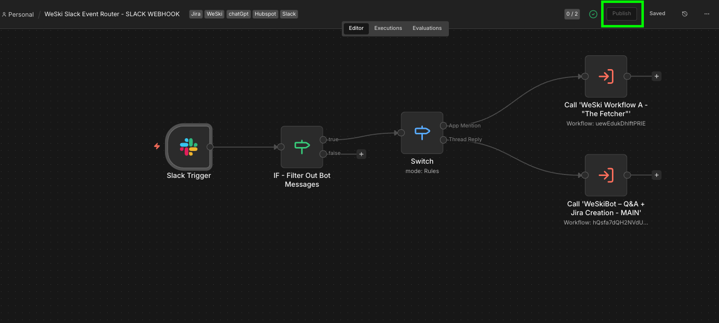
- For older n8n versions (below ver 2.0), on the n8n workflow, [Your Agency] Slack Event Router - SLACK WEBHOOK- toggle Active – for < 2.0 versions of n8n.

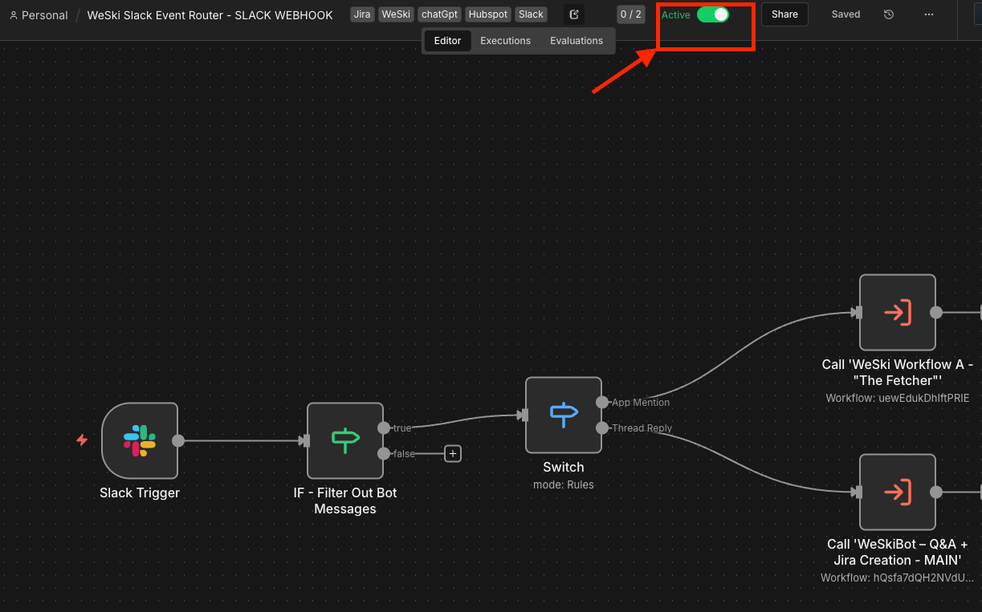

Step 7.3: Verify Slack Event Subscriptions
- Return to Slack API → Your app → Event Subscriptions
- Verify Request URL still shows green checkmark ✅
- Verify all four events are subscribed:
  - app_mention
  - message.channels
  - message.groups
  - message.im

Step 7.4: Test End-to-End
Test 1 - Initial Mention (Workflow A):
- In Slack, go to a channel with the bot
- Send: @[Your Agency] Bot 8844221 (use a real Group ID from HubSpot)
- Expected: Bot replies with confirmation of guest details
- Verify in n8n:
  - Router execution shows success
  - Switch routed to Output 0 (App Mention)
  - Workflow A execution shows success
Test 2 - Thread Reply (Workflow B):
- Reply in the thread created in Test 1
- Send: Yes
- Expected: Bot replies with answer based on HubSpot data
- Verify in n8n:
  - Router execution shows success
  - Switch routed to Output 1 (Thread Reply)
  - Workflow B execution shows success
Test 3 - Jira Ticket Creation:
- In the same thread, send a message indicating an issue
- Send: The hot tub at my hotel isn't working
- Expected:
  - Bot acknowledges the issue
  - Bot confirms ticket creation with ticket number
- Verify:
  - Check Jira for new ticket
  - Ticket should contain conversation context

8. Troubleshooting Installation

Slack Connection Issues
Problem: "Your URL didn't respond with the value of the challenge parameter"
Solutions:
- Ensure Router workflow is Active
- Verify webhook URL is correct (no trailing spaces)
- Check n8n execution logs for errors
- Confirm Code node and Respond to Webhook node are properly connected

Problem: Bot doesn't respond to mentions
Solutions:
- Verify bot is invited to the channel (/invite @BotName)
- Check Event Subscriptions are saved and verified
- Ensure app_mention event is subscribed
- Review Router execution logs for incoming events

HubSpot Connection Issues
Problem: "Authentication failed" or "Invalid API key"
Solutions:
- Verify API key is copied correctly (no extra spaces)
- Ensure Private App has required scopes (crm.objects.deals.read)
- Check if API key was regenerated (old key invalidated)

Problem: No deals found when searching
Solutions:
- Verify Group ID property name matches exactly (case-sensitive)
- Check deals in HubSpot have the Group ID field populated
- Test with a known Group ID value
- Review HubSpot node filter configuration

Jira Connection Issues
Problem: "Unauthorized" or "Authentication failed"
Solutions:
- Verify API token is correct
- Confirm email matches the token owner's account
- Check domain doesn't include https:// (just company.atlassian.net)
- Ensure you have permission to create issues in the project

Problem: "Project not found" or "Issue type not valid"
Solutions:
- Verify project key is correct (case-sensitive)
- Check issue type exists in that project
- Ensure you have "Create Issues" permission
- Review project settings for required fields

OpenAI Connection Issues
Problem: "Invalid API key"
Solutions:
- Verify key is copied correctly (starts with sk-)
- Check key wasn't revoked in OpenAI dashboard
- Ensure your OpenAI account has available credits

Problem: Rate limit or quota exceeded
Solutions:
- Check your OpenAI usage dashboard
- Add credits to your account
- Reduce request frequency or use a lower-tier model
- Implement caching for repeated queries

n8n Workflow Issues
Problem: Workflows won't activate
Solutions:
- Check for missing credentials (red indicators)
- Verify all nodes are properly connected
- Review error messages in workflow
- Ensure all required parameters are filled

Problem: Execute Workflow nodes can't find sub-workflows
Solutions:
- Verify Workflow A and B are saved (not drafts)
- Check workflow names match exactly in Execute Workflow nodes
- Ensure sub-workflows are in the same n8n instance
- Try re-selecting the workflow in the dropdown

9. Post-Installation Checklist
Before going live, verify:
- All three workflows are Active and showing green status
- Slack Event Subscriptions shows ✅ Verified
- Bot responds to test @mention with HubSpot data
- Thread replies generate AI responses
- Jira tickets are created when issues are mentioned
- Bot is invited to all relevant Slack channels
- All credentials are securely stored (not in plain text)
- OpenAI usage limits are set to prevent unexpected costs
- Team members know how to monitor n8n execution logs

The 3 Core Workflows (n8n)
The logic for this solution is split into three distinct workflows to handle the "conversation state."
Workflow A: [Your Agency] Slack Event Router - SLACK WEBHOOK

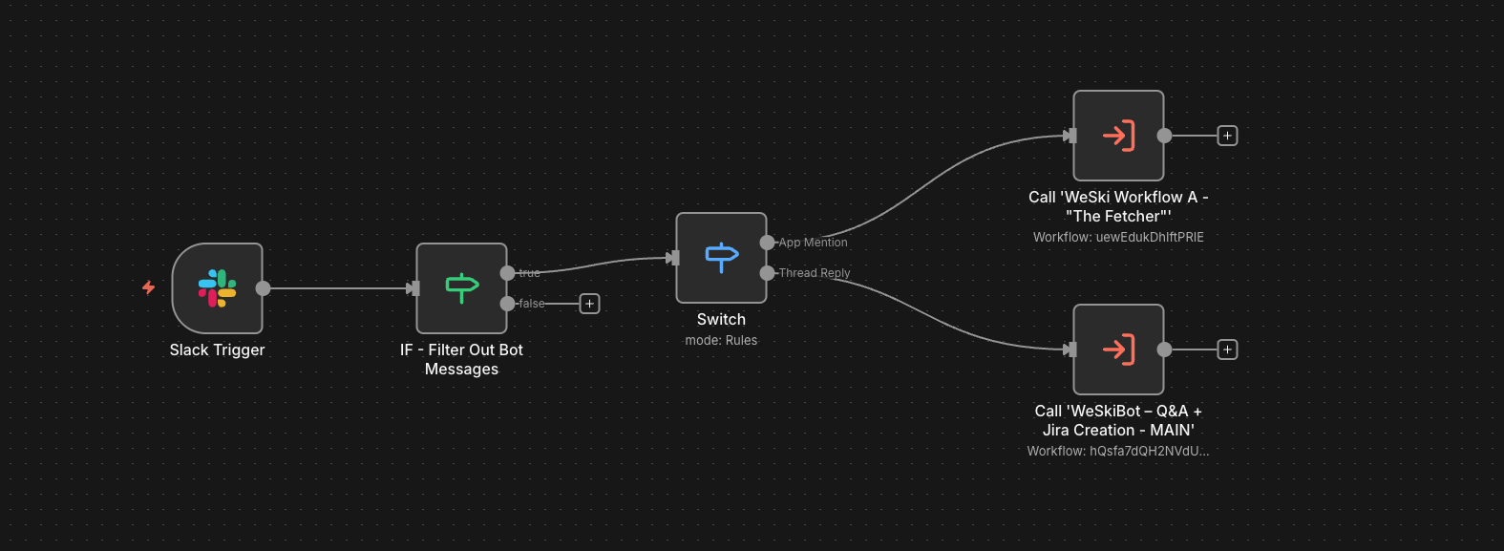
Purpose: Acts as the central entry point for all Slack events, verifying requests and intelligently routing messages to the appropriate workflow.
Trigger: Slack Trigger node (uses Slack API credentials configured in n8n)
Process Flow:
- Slack Trigger: Receives events directly from Slack via n8n's built-in Slack integration. No manual webhook or URL verification setup required.
- Bot Message Filter (IF): Prevents infinite loops by filtering out the bot's own messages.
  - Condition: Event user ≠ Bot authorization user
  - TRUE: Continue to routing
  - FALSE: End execution
- Event Router (Switch): Determines message type and routes accordingly.
  - Output 0 - App Mention: Messages without thread_ts (initial mentions) → Routes to Workflow A
  - Output 1 - Thread Reply: Messages with thread_ts (ongoing conversations) → Routes to Workflow B
- Execute Sub-Workflows:
  - Calls Workflow A for new conversations
  - Calls Workflow B for thread replies

Workflow B: [Your Agency] Workflow A - "The Fetcher"

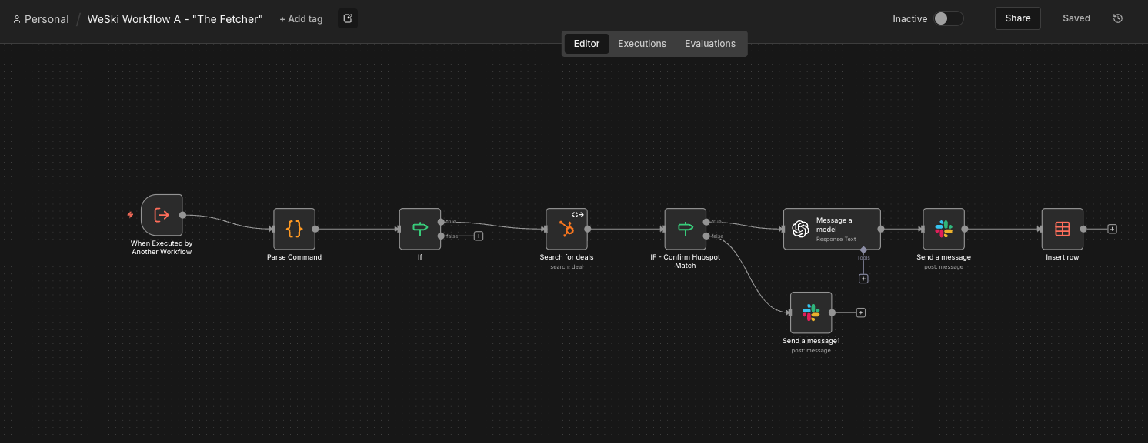
Purpose: Handles the initial interaction when a user mentions the bot, extracts the booking ID, retrieves guest information from HubSpot, and confirms the details via AI.
Trigger: Execute Sub-Workflow Trigger (called by Router when new app mention detected).
Process Flow:
- Trigger: Receives event data from Router containing user message.
- Step 1 (Clean): Extracts the numeric Group ID from the user's message using Regex.
  - Example Input: @[Your Agency] Bot 8844221
  - Output: 8844221
- Step 2 (Lookup): Searches HubSpot Deals for the specific group_id.
  - Query: Deal properties where group_id matches extracted number
  - Retrieved Data: Guest Name, Hotel, Check-in dates, Package details, etc.
- Step 3 (AI Brain): Sends retrieved data to OpenAI with a system prompt:
  - System Prompt: "You are [Your Agency] Assist. Confirm you found [Guest Name] at [Hotel]."
  - AI Response: Natural language confirmation with booking details
- Step 4 (Reply): Posts the AI-generated confirmation back to the Slack thread.
  - Method: Creates a new thread or replies in channel
  - Content: Personalized confirmation message from AI

Workflow C: [YourAgency]Bot – Q&A + Jira Creation - MAIN
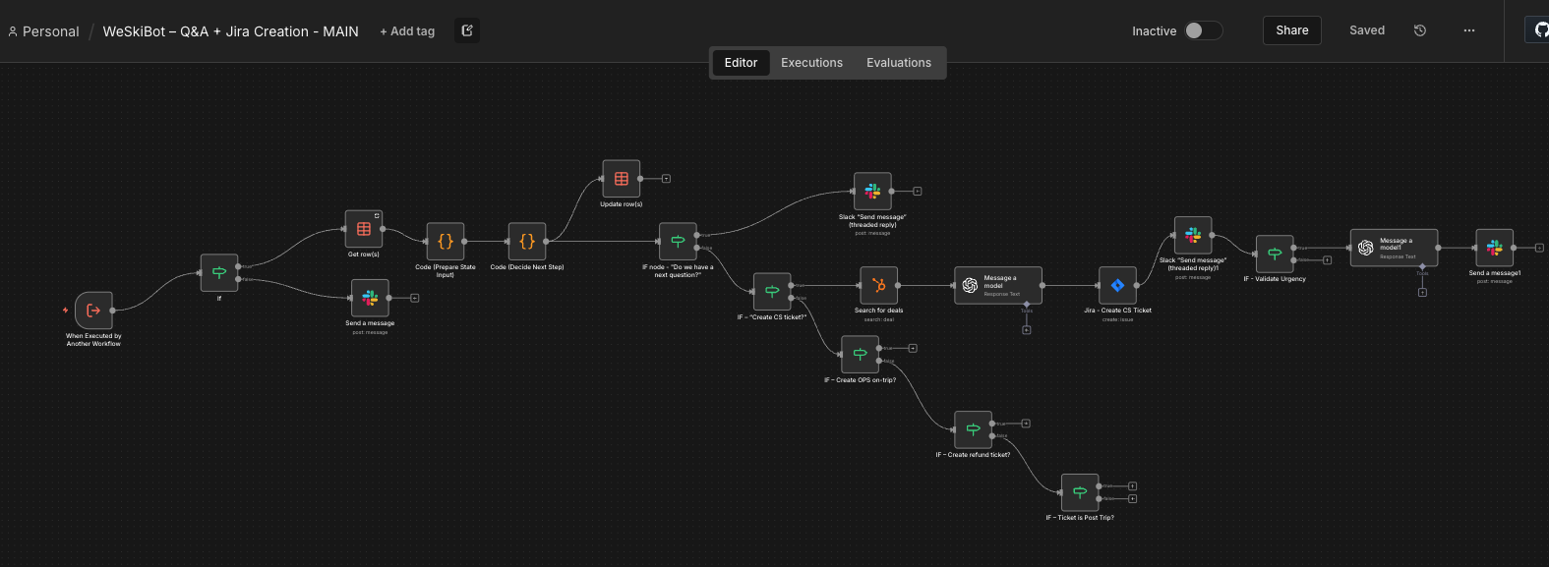

Purpose: Handles all thread replies after the initial mention, providing conversational AI responses and creating Jira tickets when service issues are identified.
Trigger: Execute Sub-Workflow Trigger (called by Router when thread reply detected).
Process Flow:
- Trigger: Receives thread reply event data from Router.
- Step 1 (Context Retrieval): Fetches the full conversation thread from Slack.
  - Method: Uses thread_ts to retrieve all messages in the thread
  - Purpose: Provides conversation history to AI for context
- Step 2 (HubSpot Lookup): Re-retrieves guest data from HubSpot Deals.
  - Query: Uses stored group_id from initial conversation
  - Purpose: Maintains access to booking details throughout conversation
- Step 3 (AI Response): Sends user question + context + guest data to OpenAI.
  - System Prompt: "You are [Your Agency] Assist. Answer guest questions about their booking. If there's an issue requiring attention, indicate ticket creation."
  - Context: Full thread history + HubSpot guest data
  - Output: Natural language response
- Step 4 (Issue Detection - IF): Analyzes AI response for service issue keywords.
  - Condition: Response contains "ticket", "issue", "problem", "maintenance", etc.
  - TRUE: Proceed to Jira ticket creation
  - FALSE: Skip to posting reply
- Step 5 (Jira Ticket - Conditional): Creates service ticket in Jira Service Management.
  - Ticket Fields:
    - Summary: Brief description of issue
    - Description: Full context from conversation
    - Reporter: Guest name from HubSpot
    - Labels: Group ID, booking reference
  - Output: Jira ticket key (e.g., "SUPPORT-123")
- Step 6 (Confirm Ticket): If ticket created, AI generates confirmation message.
  - Prompt: "Confirm that ticket [TICKET-123] was created for [issue]"
  - Output: Professional confirmation with ticket reference
- Step 7 (Reply): Posts AI response (with or without ticket reference) to Slack thread.
  - Method: Replies in existing thread using thread_ts
  - Content: Contextual AI response

3. Data Flow Strategy
The most complex part of this solution is ensuring the Group ID (8844221) survives the conversation.
- Input: User types it (@Bot 8844221).
- HubSpot: n8n verifies it exists.
- Thread History: When the user replies with the issue, n8n looks backwards to grab the ID again.
- Metadata: When the bot presents buttons, it hides the ID inside the button payload.
- Jira: When the button is clicked, the ID is unpacked and sent to Jira.

Current Status
- ✅ HubSpot Connection: Working (Pulling custom fields).
- ✅ OpenAI Persona: Working (Natural responses).
- ✅ Thread Context: Working (Bot knows which booking is being discussed).
- ⚠️ Jira Wiring: The final logic to map the specific "Urgency" field in Jira (Workflow C) is the next immediate build step.

4. Installation Instructions
- Import Workflows:
  - Log into n8n.
  - Go to Workflows > Import from File.
  - Upload the provided .json files.
- Connect Credentials:
  - Open the workflow. You will see nodes marked with warning signs.
  - Double-click the Slack, HubSpot, Jira, and OpenAI nodes.
  - Select "Create New Credential" and enter your API Keys for each service.
- Configure Data Table:
  - Open the Get row(s) and Update row(s) nodes.
  - Ensure they are pointing to the conversation_state table you created in Step 3.
- Activate:
  - Toggle the workflow to Active (Top right switch).

⚙️ Jira Set Up Guide

1. Project & Workflow Setup
This solution requires two distinct Jira Service Management (JSM) projects to separate frontline support from operations/finance tasks.

A. Create Projects (Spaces)
- Project 1: [Your Agency] Customer Service
  - Project Key: CS (or similar)
  - Template: IT Service Management or General Service Desk.
  - Purpose: Receives all initial tickets created by the Slack Bot.
- Project 2: [Your Agency] OPS Support
  - Project Key: OPS
  - Template: IT Service Management.
  - Purpose: Handles escalated issues and refund requests.

B. Configure Issue Types
Ensure the following Issue Types exist in their respective projects. You may need to create them in Jira Settings > Issues > Issue Types and associate them with your projects.
- In CS Project:
  - CS Support Ticket (Standard task for general inquiries)
- In OPS Project:
  - OPS Support Ticket (For urgent/escalated on-trip issues)
  - OPS Refund Ticket (For finance-related tasks)

2. Custom Field Configuration
The automation relies on specific custom fields to route tickets and store data captured by the bot.

Create the Fields
Go to Jira Settings (⚙️) > Issues > Custom Fields and create:
- Field Name: Next Action
  - Type: Short Text (read-only recommended).
  - Purpose: Acts as the "Trigger" for automation rules. The n8n bot writes a specific value here (e.g., "Resolved by OPS - Refund Required"), and Jira Automation reads it to decide what to do next.
- Field Name: Refund Amount
  - Type: Short Text (or Number).
  - Purpose: Stores the specific amount (e.g., "$150") captured by the bot during the triage chat.
⚠️ Important: After creating these fields, you must add them to the Screens (Create/Edit/View screens) for both the CS and OPS projects, or the API will fail to write data to them.

3. Automation Rules Setup
You need to import or manually recreate the following automation rules in Jira. These rules listen for changes in the Next Action field (set by the bot) and route the ticket accordingly.

How to Import Rules:
- Go to Project Settings > Automation.
- Click the ... (Three dots) in the top right > Import Rules.
- Upload the .json files provided in the artifact package.

Rule Dictionary
Rule Name | Trigger Condition | Action Performed
Resolved without OPS - No Refund Required | Next Action = "Resolved without OPS - No Refund Required" | • Transitions issue to Done.  • Posts comment: "No further action required."
Resolved without OPS - Refund Required | Next Action = "Resolved without OPS - Refund Required" | • Transitions issue to Done.  • Clones issue to OPS Project (Type: OPS Refund Ticket).  • Links new ticket to original.
Resolved By OPS - No Refund Required | Next Action = "Resolved by OPS - No Refund Required" | • Transitions issue to Done.  • Clones issue to OPS Project (Type: OPS Support Ticket).  • Alerts team via Slack.
Resolved By OPS - Refund Required | Next Action = "Resolved by OPS - Refund Required" | • Transitions issue to Done.  • Clones issue to OPS Project (Type: OPS Refund Ticket).  • Alerts team via Slack.
Unresolved - Escalate to OPS | Next Action = "Unresolved - Escalate to OPS" | • Updates Summary with "CS COPY".  • Clones issue to OPS Project (Type: OPS Support Ticket).  • Sets OPS ticket priority to High.
Unresolved Urgent - Escalate to OPS | Next Action = "Unresolved Urgent - Escalate to OPS" | • Updates Priority to Highest.  • Clones to OPS Project.  • Sends "Urgent" Slack Alert to #cs-ops-emergency.
Auto-Handover Unresolved Tickets (>12h) | Scheduled: Every 1h (JQL: created < -12h AND resolution = Unresolved) | • Transitions status to Handover.  • Adds comment alerting the team.
Auto-Move Post-trip complaints board (>10d) | Scheduled: Daily (JQL: created < -10d AND resolution = Unresolved) | • Moves ticket to "Post-Trip" board/status.  • Adds comment explaining the move.

